CLOUD COMPUTING

**Assignment 01**

**Name:** Abiha Nadeem

**Roll no:** 2023-BSE-001

**Submitted to:** Sir. Waqas Saleem

Task 1: Run Gitea in Codespace and Create an Initial Repo

1. **Set up Gitea**

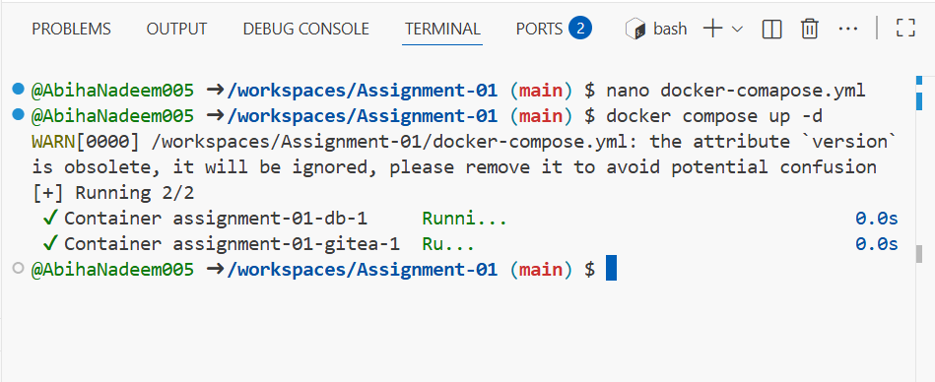

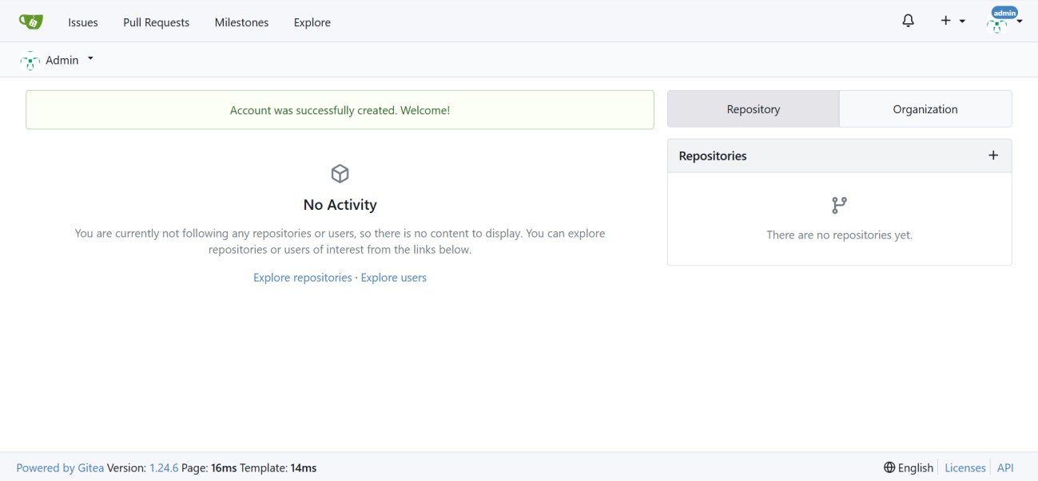

**Add Remote Repo:**

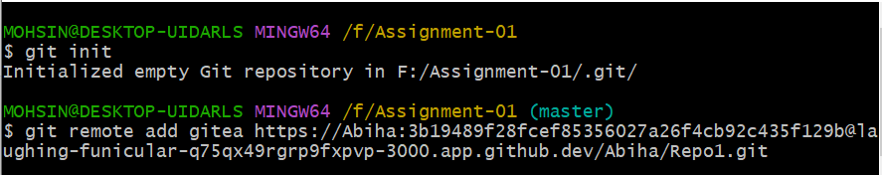

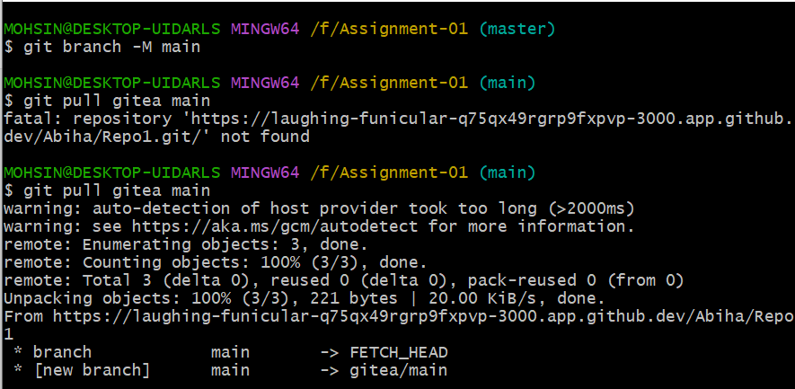

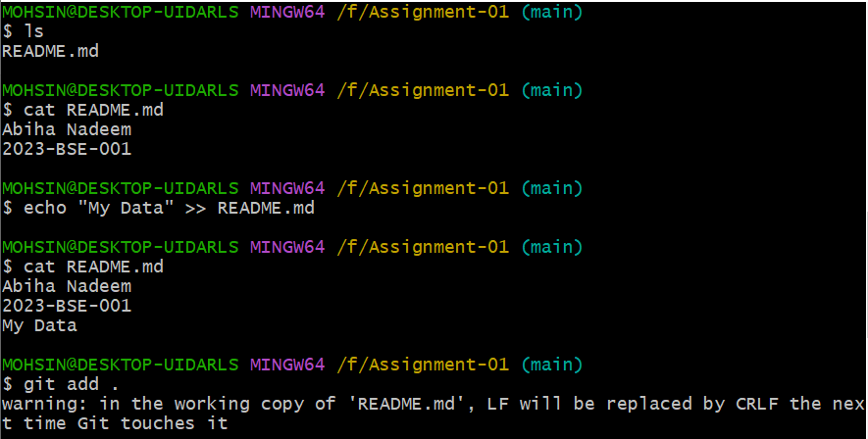

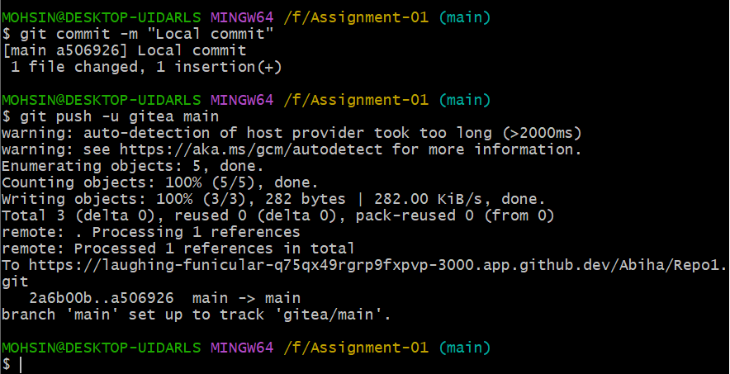

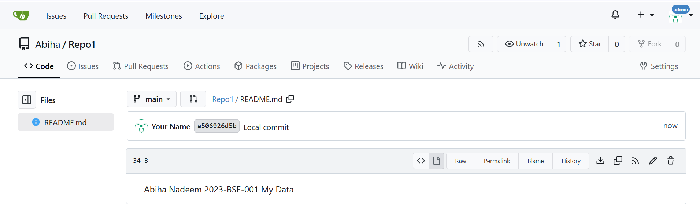

Task 2: Mirror README.md from Gitea to GitHub

**Create GitHub Repository:**

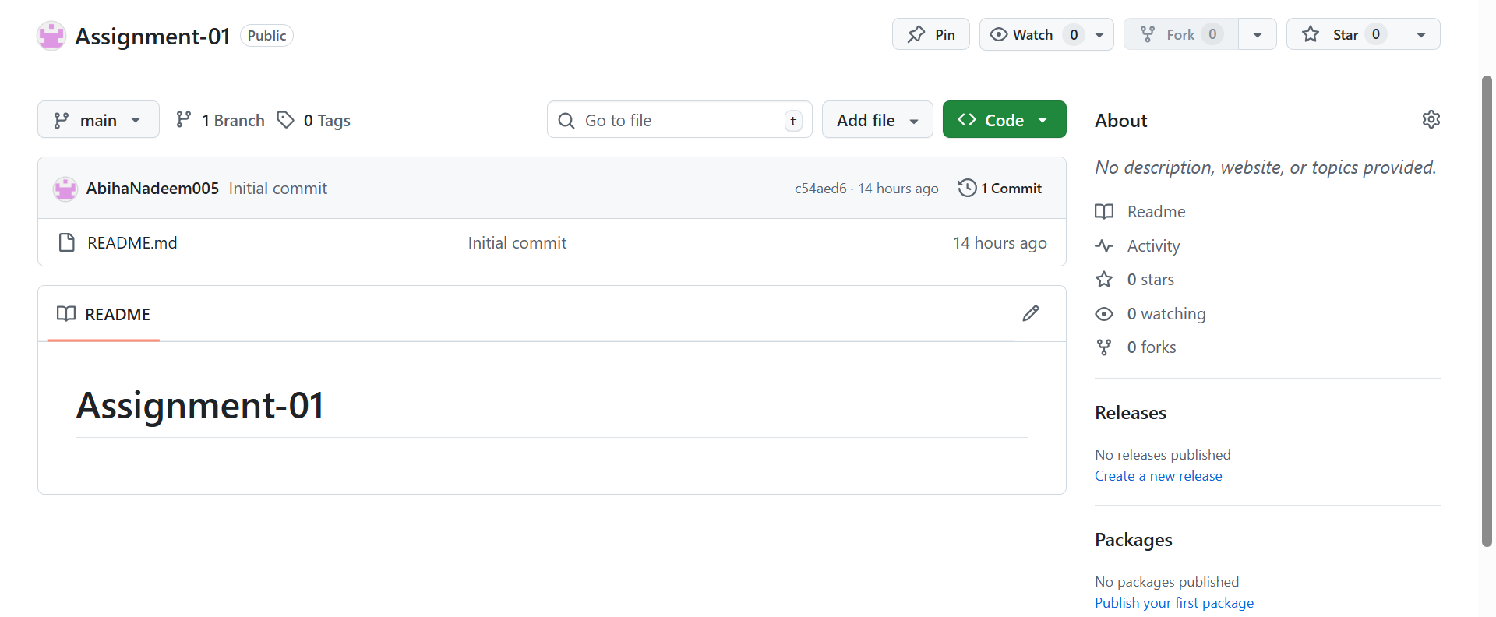

Add GitHub as a Second Remote:

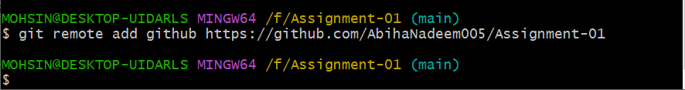

Push the README.md File to GitHub:

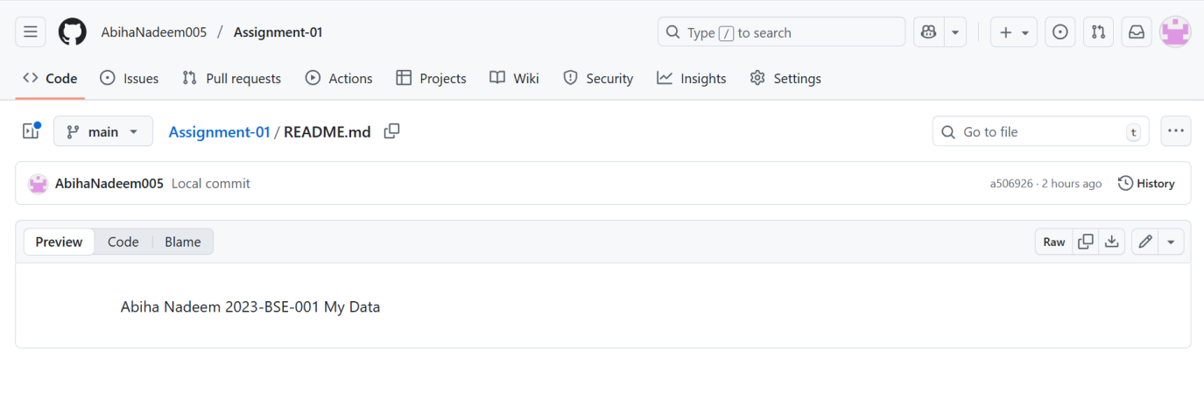

Verify Remotes:

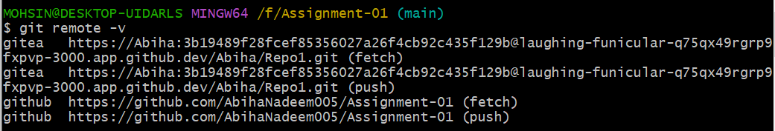

## Task 3: Use Git LFS for Large Files

**Install Git LFS:**

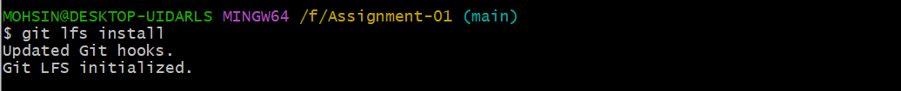

**Add Large Files:**



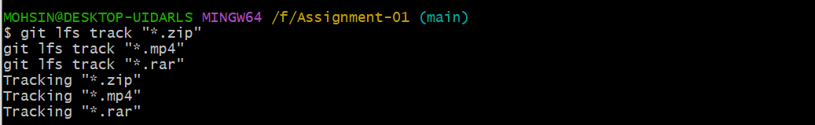

****Reference in Assignment Repo:****

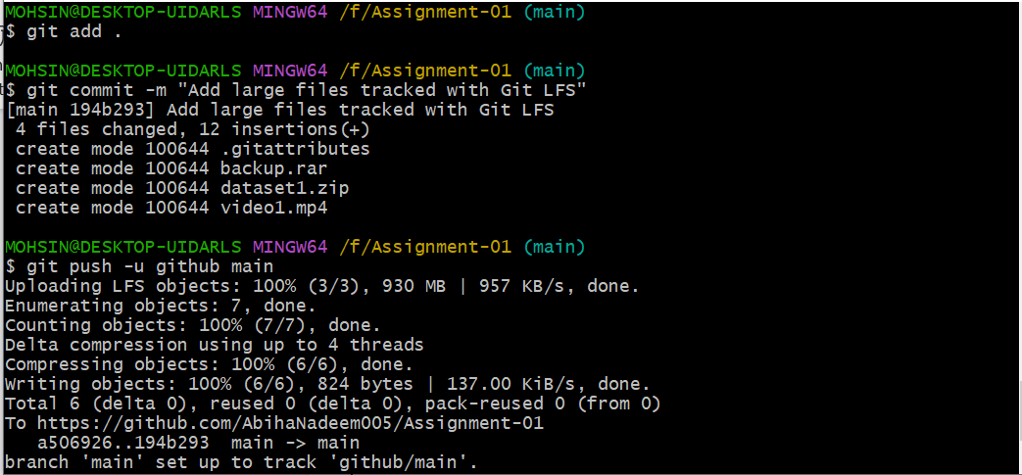

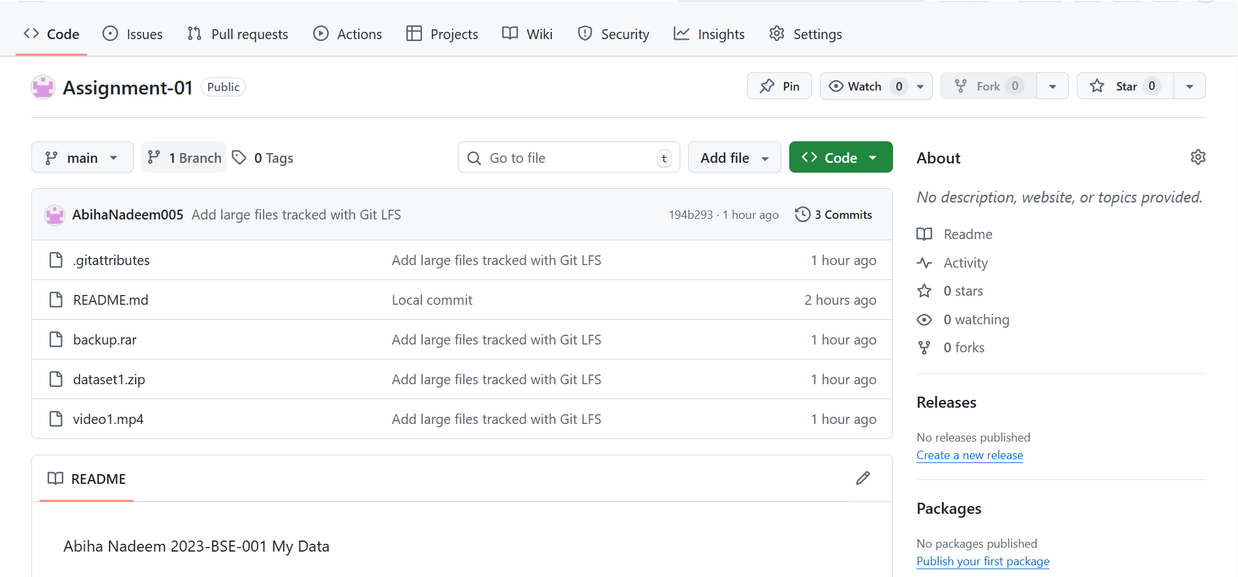

## Task 4: Create a Portfolio/CV with GitHub Pages

**Create a new repository for GitHub Pages:**

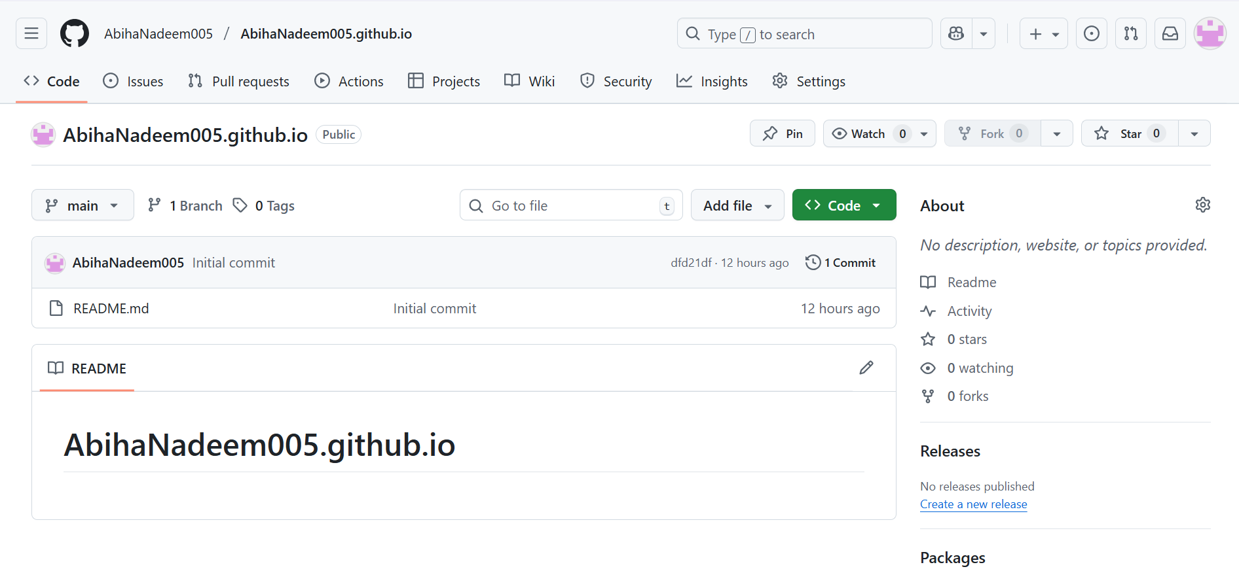

****Publish with GitHub Pages:****

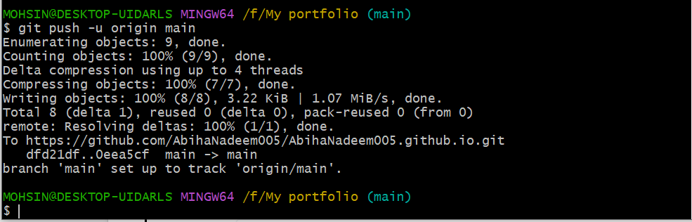

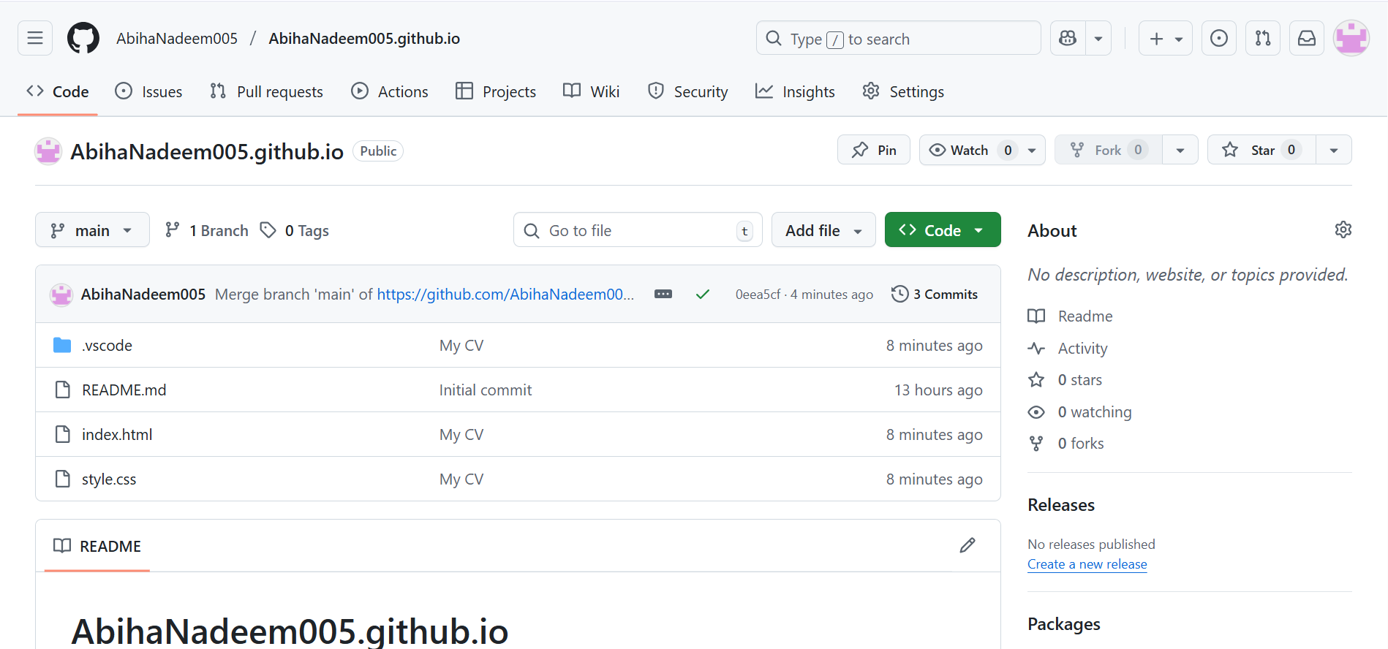

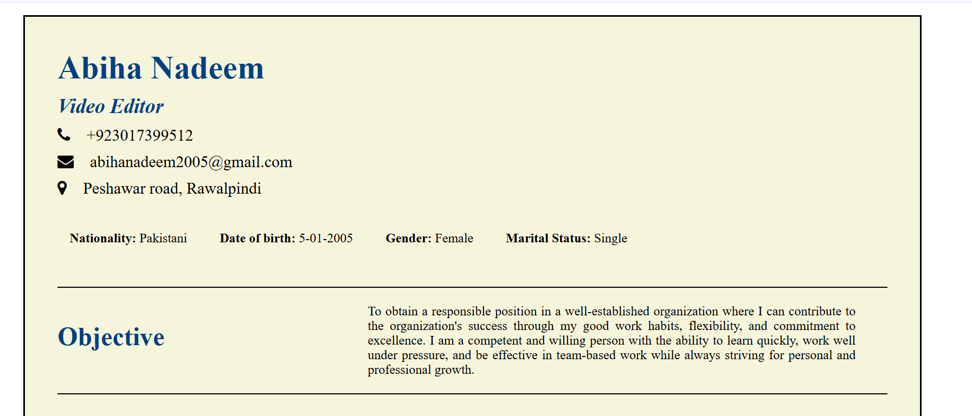

<https://abihanadeem005.github.io/>

<https://github.com/AbihaNadeem005/Assignment-01>

********************